Table of Contents

FUNCTION APPS 2

CREATING A FUNCTION APP 2

CREATING FUNCTION IN FUNCTION APP 3

TESTING THE FUNCTION 3

# FUNCTION APPS

## CREATING A FUNCTION APP

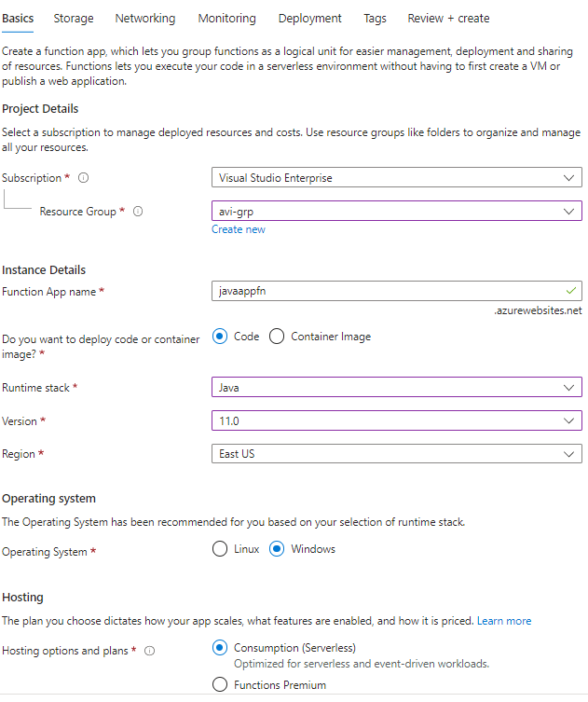

* We need to create storage account to manage triggers and the logging for Azure function

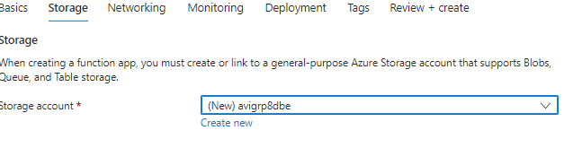

## CREATING FUNCTION IN FUNCTION APP

* Function with HTTP trigger

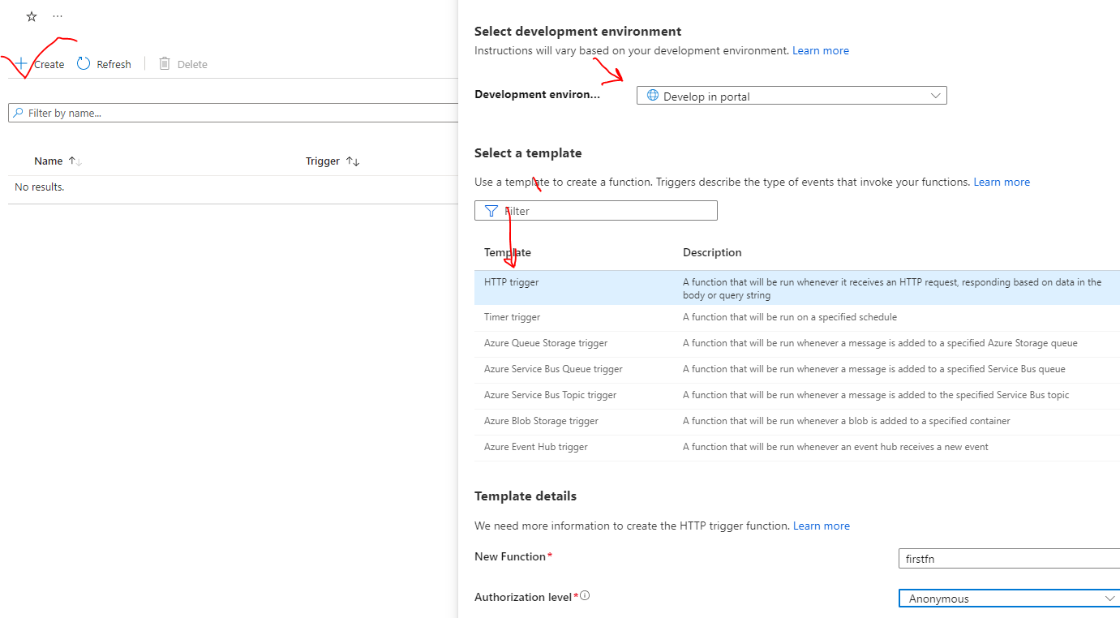

### TESTING THE FUNCTION

SAMPLE .NET BASED FUNCTION

|  |
| --- |
| #r "Newtonsoft.Json"  using System.Net;  using Microsoft.AspNetCore.Mvc;  using Microsoft.Extensions.Primitives;  using Newtonsoft.Json;  public static async Task<IActionResult> Run(HttpRequest req, ILogger log){  log.LogInformation("C# HTTP trigger function processed a request.");  string name = req.Query["name"];  string requestBody = await new StreamReader(req.Body).ReadToEndAsync();  dynamic data = JsonConvert.DeserializeObject(requestBody);  name = name ?? data?.name;  string responseMessage = string.IsNullOrEmpty(name)  ? "This HTTP triggered function executed successfully. Pass a name in the query string or in the request body for a personalized response."  : $"Hello, {name}. This HTTP triggered function executed successfully.";  return new OkObjectResult(responseMessage);  } |

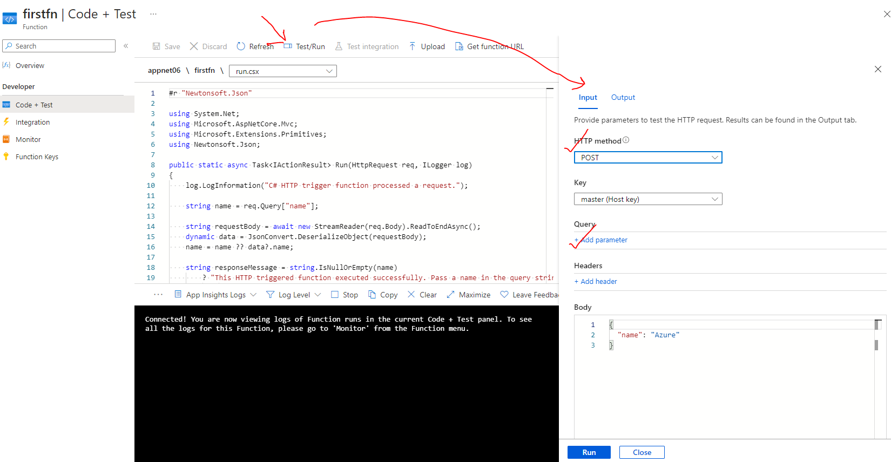

#### TESTING GET REQUEST

|  |  |
| --- | --- |
| INPUT | OUTPUT |
|  |  |

#### TESTING POST REQUEST

|  |  |
| --- | --- |
| INOUT | OUTPUT |
|  |  |

#### EXECUTING THE FUNCTION FROM BROWSER

* To execute the function from the browser🡪 Copy the function URL from the Get URL option

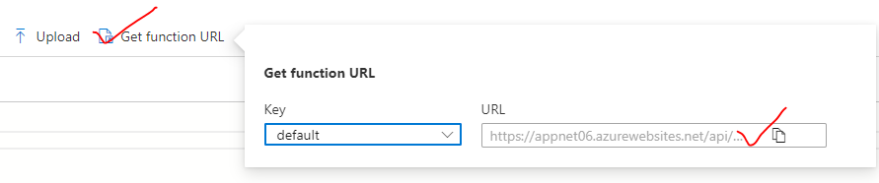

## CREATING FUNCTION IN EDITOR(INTELLIJ)

* File 🡪 New Project
* Note – to run locally – we need have **Azure Core Tools**

|  |  |
| --- | --- |
|  |  |
| Host.json  {  **"version"**: **"2.0"**,  **"extensionBundle"**: {  **"id"**: **"Microsoft.Azure.Functions.ExtensionBundle"**,  **"version"**: **"[3.*, 4.0.0)"** } } | local.settings.json  {  **"IsEncrypted"**: **false**,  **"Values"**: {  **"AzureWebJobsStorage"**: **""**,  **"FUNCTIONS_WORKER_RUNTIME"**: **"java"**,  **"FUNCTION_APP"**: **"MyHttpExample"** } } |

COMMAND TO RUN THE FUNCTION APP LOCALLY

|  |  |
| --- | --- |
| BUILDING THE FUNCTION APP | **mvn clean package** |
| RUNNING THE FUNCTION APP LOCALLY | **mvn azure-functions:run** |
| RUNNING FUNCTION IN LOCAL – Use the below URL to access execute the function application | |

### DEPLOYING FUNCTION IN PORTAL

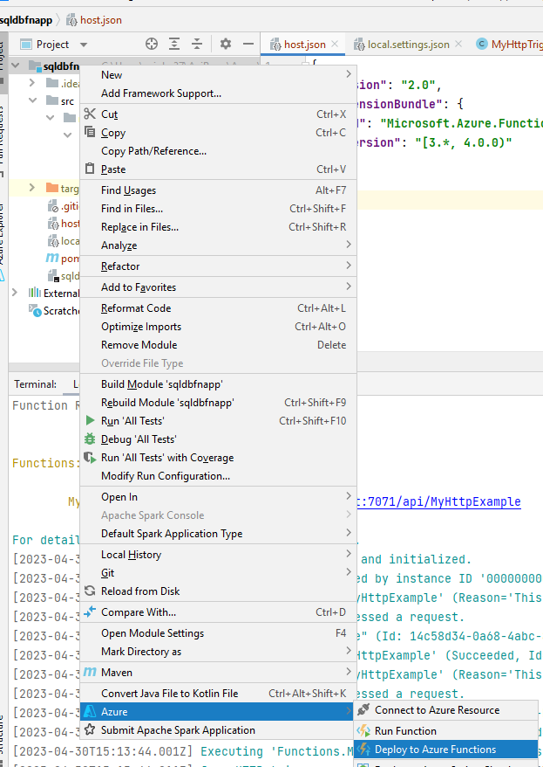

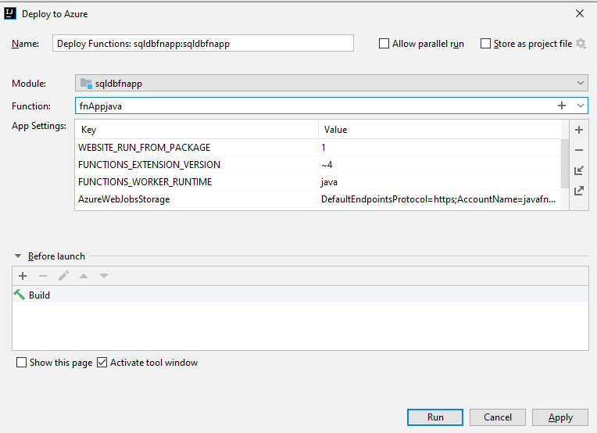

### FUNCTION APP DEPLOYED TO PORTAL

